Press Release
Date

Release date 31 March 2016
Revised advice for owners of tumble dryers
Owners of some tumble dryers manufactured between April 2004 and September 2015 are being advised to check if they require a safety modification.
Identified models of Hotpoint, Indesit, Swan, Proline and Creda tumble dryers are subject to manufacturer’s product recall notices as there is a risk of fire caused by fluff coming into contact with heating elements.
The manufacturers have activated an extensive action plan to provide consumers with products that are updated to higher safety and quality standards. An engineer will visit, free of charge, to modify the appliance.
Fire Investigation Manager Andy Justice, of Devon & Somerset Fire & Rescue Service, said: “Nationally, we are aware that these tumble dryers have been responsible for causing fires and manufacturers’ advice has been issued previously for their use.
“Now with revised advice, we wish to bring this to the attention of consumers of affected tumble dryers that they follow the manufacturers’ instructions where they should be unplugged and not used until the modification has taken place.”
To establish whether your tumble dryer is affected by this recall, further information can be found by following the below links or using the Freephone hotline:
http://safety.indesit.eu http://safety.hotpoint.eu http://safety-swan.eu
Creda and Proline customers should visit http://safety.hotpoint.eu
Freephone hotline at 0800 151 0905
If your product has a green "dot" sticker in the door area or on the back plate, no action is required. A graphic showing the location of the green dots is here: https://safety.indesit.eu/gb/match.jsp?lang=
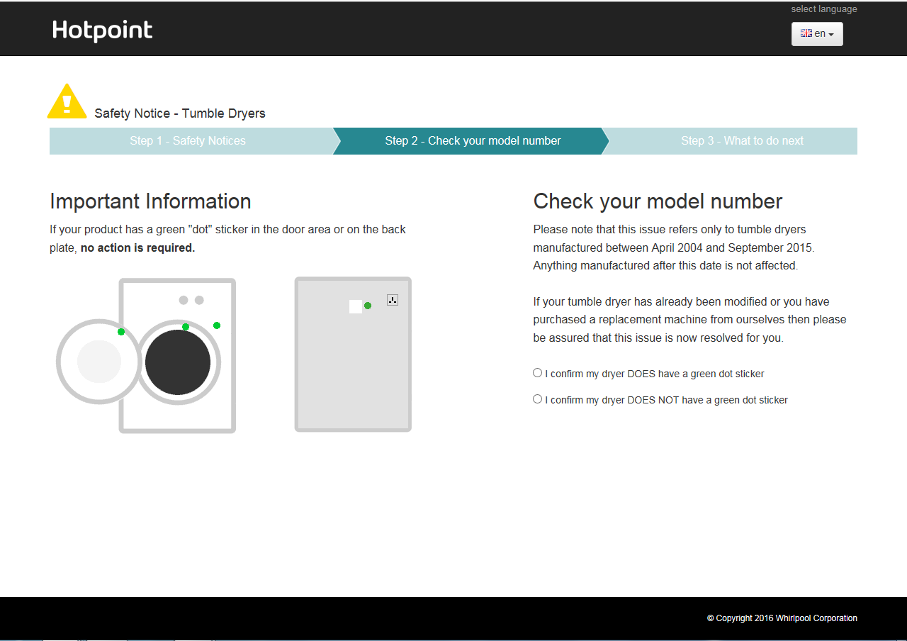
Ends
For more press information please contact:
Paul Slaven
PR Officer
01392 872259
pslaven@dsfire.gov.uk
Keep up to date and follow ‘dsfireupdates’ on Twitter and Facebook

