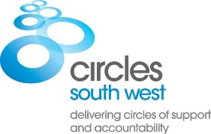
Volunteer to help prevent sexual abuse: new volunteering opportunities in
Bristol, Bath and North East Somerset, North Somerset, South Gloucestershire and Somerset

As a Volunteer in a Circle of Support and Accountability (‘Circle’), you’ll make an important contribution to preventing sexual abuse by helping reduce the risk of further sexual harm by a known perpetrator.

A Circle is a small group of carefully trained and selected Volunteers who meet regularly with an individual who has been convicted of sexual offences (or with harmful sexual behaviour). Volunteers hold the individual to account for their behaviour and support their safe reintegration into the community. They work closely with the responsible statutory organisations.

We are now recruiting for the following exciting new volunteering opportunities:
- Prison Project (starting Circles for adults in prison, through the gate and on into the community)
- Young People’s Service (Circles for young people aged 14-20 years)
- Circles for adults with Intellectual Disabilities

We welcome adult Volunteers from all walks of life who are approachable, emotionally stable and have a mature outlook. The ability to maintain firm boundaries is essential. You will need to commit around 2 hours per week for 12-18 months. We provide full training, ongoing professional support and reimburse expenses. Appointment is dependent on satisfactory references and an Enhanced DBS Check.

Find out more here https://www.circles-uk-volunteers.org/ and here www.circlessw.org.uk

For an application pack contact Circles South West on 07738 947988 or at volunteering@circlessw.org.uk

