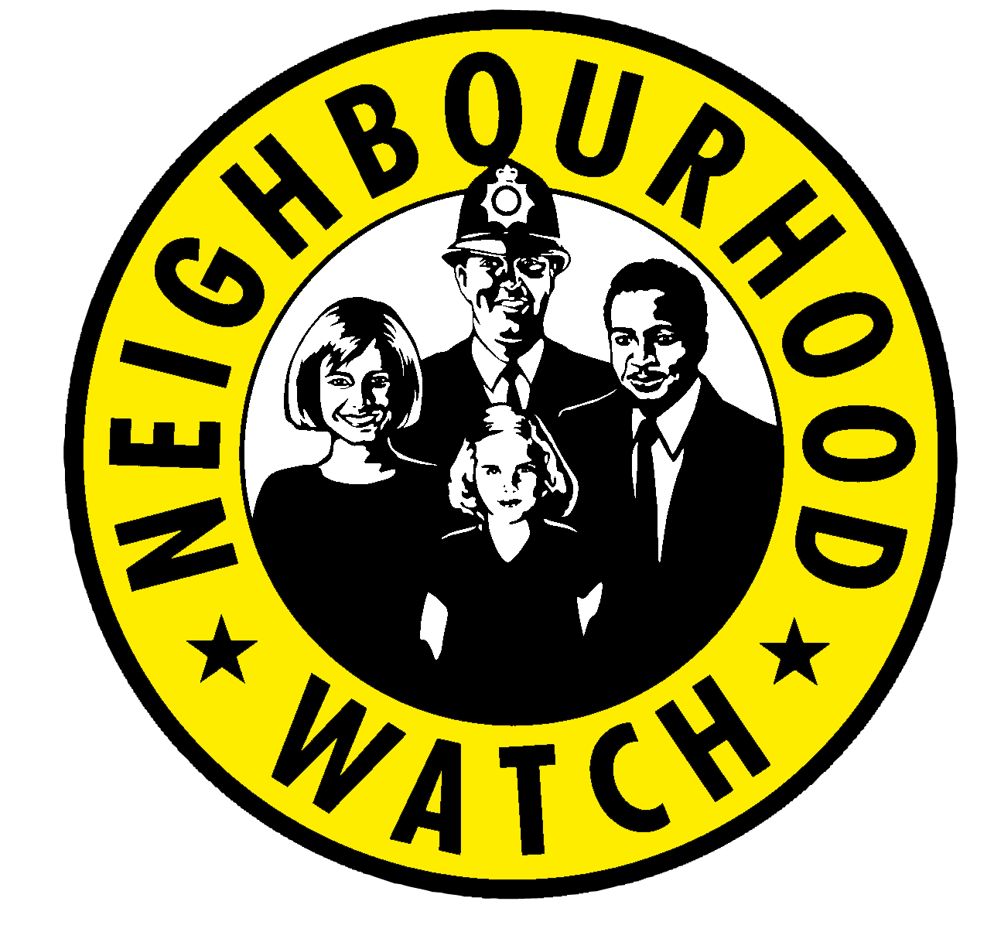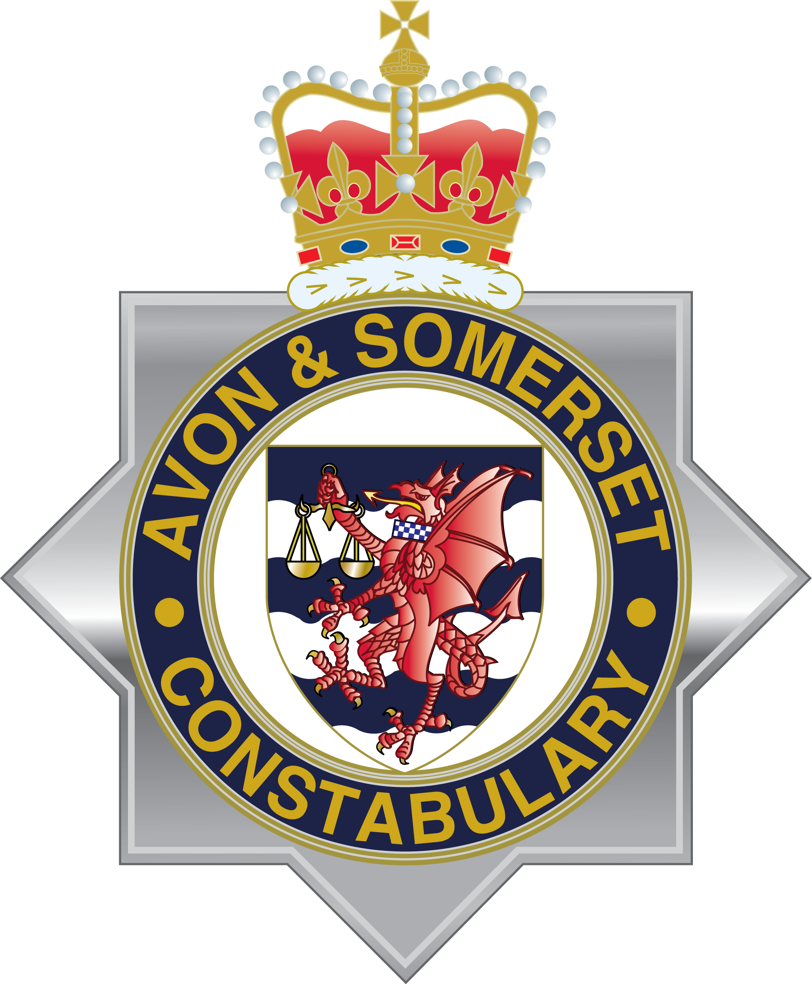
Update from the Avon and Somerset Neighbourhood Watch Association
23 May 2017
Chief Constable Andy Marsh and Police and Crime Commissioner Sue Mountstevens met with members of the newly formed Avon and Somerset Neighbourhood Watch Association (ASNWA) Interim Committee to sign a new Memorandum of Understanding (MoU) on Thursday 18 May.
The Association is a force level body within the National NHW Network and the Interim Committee hope it will provide support for NHW across Avon and Somerset. The signing of the MoU, marks the official launch of the formal relationship between the Association and the Constabulary.
The Association’s Interim Chair, Dr Egils Praulitis, said: “I am delighted that we are able to sign this Memorandum of Understanding with the Constabulary and the PCC. This marks a very positive step forward for Neighbourhood Watch in Avon and Somerset.
“Our aim is to provide support to our membership and to work with the police to further develop the role of Neighbourhood Watch and make it more effective and proactive, helping to prevent crime and bring people together to establish cohesive and solid communities.
“The Constabulary is developing a Citizens Syllabus, and we will be working with them to help create masterclasses to help Neighbourhood Watch Coordinators support their schemes, to share best practice, new ideas, and to ensure that together we are providing our volunteers with the skills and knowledge they need to deliver the best possible service.”
Chief Constable Andy Marsh said: “Neighbourhood Watch has long been a valuable partner to both the Constabulary and our local communities. The further development of the Association and the signing of this Memorandum will strengthen the working relationship between the police and Neighbourhood Watch, which can only be of benefit to the public.
“It is vital we all work together not only to prevent crime but to ensure we create unified communities where everyone, particularly the most vulnerable in our society, feel safe. Neighbourhood Watch can play a huge part in helping to achieve this and I am grateful to all the volunteers involved across Avon and Somerset.”

Avon and Somerset Police and Crime Commissioner Sue Mountstevens said: “I’m delighted that Avon and Somerset now officially has its own Neighbourhood Watch Association. The signing of the Memorandum of Understanding demonstrates the importance that both the Chief Constable and I place on the volunteer watch schemes operating across Avon and Somerset.
“Neighbourhood Watch is essential in keeping our communities safe. It gives local people a vital role in passing on crucial information, looking out for fellow residents and ensuring we’re all doing all we can to fight crime and bring offenders to justice.”
Dr Praulitis added: “All NW co-ordinators and NW schemes within the Avon and Somerset force area are automatically part of this new Association. We are looking for people to join the Interim Committee to help us move forwards, define and influence our next steps and to provide new skills and perspective to refresh the path of Neighbourhood Watch in Avon and Somerset.

“The Association wants to hear from you. Please visit the new website https://www.asnwa.org/ to get more information about the ASNWA and send in your questions and suggestions online. We will create a FAQ section where we can reply and start working through the issues you raise. There is also an opportunity for those with IT and media skills to help us develop our online provision, there is more information and contact details on our website.
“We will keep you up-to-date with further developments over the coming month as we move forwards and agree our next steps. You can also follow us on Twitter @asnwassociation and like us on Facebook accounts (search Avon & Somerset Neighbourhood Watch Association) for our latest news.”

