Volunteer to help prevent sexual abuse in Avon and Somerset 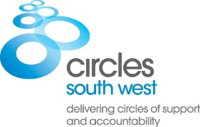
As a Volunteer in a ‘Circle of Support and Accountability’, you’ll make an important contribution to preventing sexual abuse by helping reduce the risk of further sexual offending by a known perpetrator.

A Circle of Support and Accountability is a small group of carefully trained and selected Volunteers who meet regularly with an individual who has been convicted of sexual offences (or with harmful sexual behaviour). Volunteers hold the individual to account for their behaviour and support their safe reintegration into the community. They work closely with the responsible statutory organisations.

We need more adult Volunteers in Avon and Somerset from all walks of life who are approachable, emotionally stable and have a mature outlook. The ability to maintain firm boundaries is essential. Volunteers are asked to commit around 2 hours per week for 12-18 months. We provide full training, ongoing professional support and reimburse expenses. Appointment is dependent on satisfactory references and an Enhanced DBS Check.

Find out more here https://www.circles-uk-volunteers.org/

For an application pack contact Lucy at Circles South West on 07738 947988 or at volunteering@circlessw.org.uk

Circles South West is a registered charity supported by Avon & Somerset Police and Crime Commissioner, the National Probation Service and the Big Lottery Fund.

