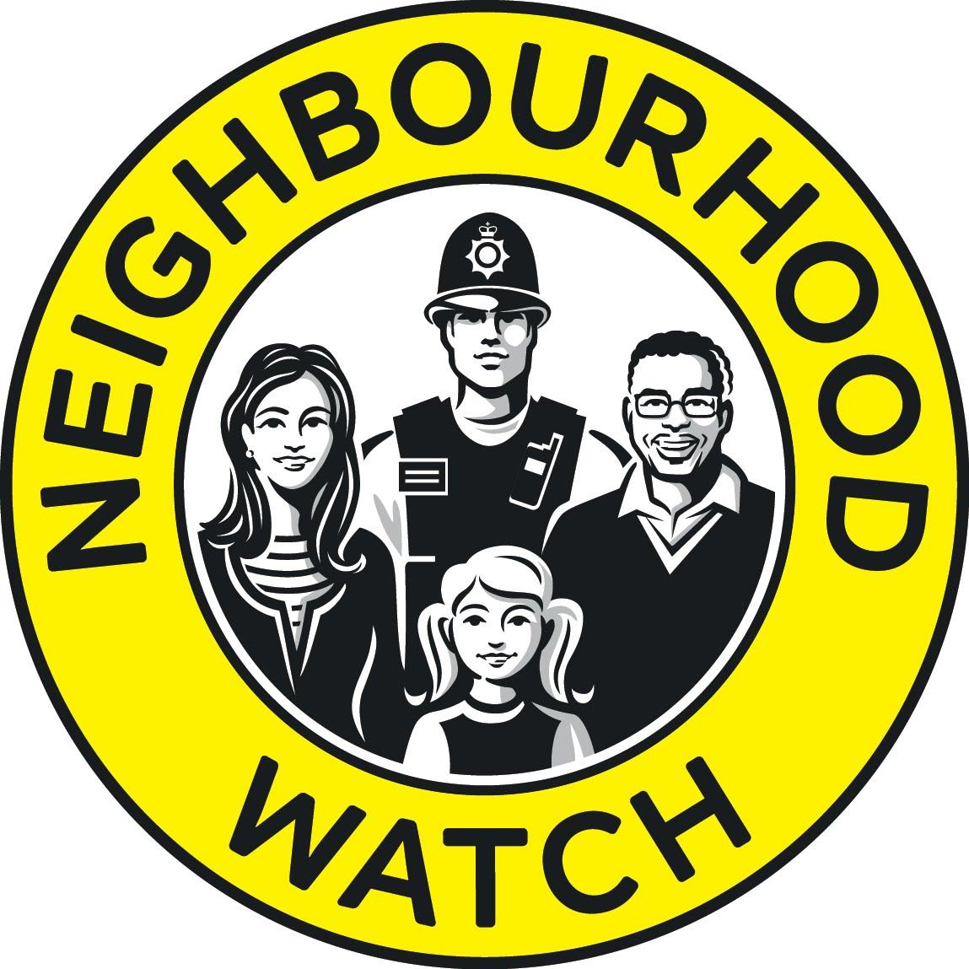
Avon and Somerset Neighbourhood Watch Association
Tel: 03330 142815 | Web | Twitter | Facebook | LinkedIn

Subject: Neighbourhood Watch - Avon and Somerset Association – Coordinator Masterclass
To: All Neighbourhood Watch Coordinators in Avon and Somerset
From: info@asnwa.org

Dear Coordinators and Deputies,
The Avon and Somerset Neighbourhood Watch Association, working with the Avon and Somerset Constabulary, would like to invite you to an

Coordinator Masterclass

On Saturday 28th October at Portishead Police & Fire Headquarters
from 10am to 4pm

Have you ever wanted to learn specialist skills to help your Neighbourhood Watch?
This is an event to provide additional ideas, and practical skills to help you run your watch.
The day will comprise a series of Police workshops to provide practical knowledge that you can take home and use in your watch. There is an opportunity to directly influence how ASNWA works for you.
Learn to improve your skill set as a coordinator, how to promote watches, how to become more involved and how to forge relationships with your local policing beat teams. There will also be practical crime reduction advice and will have some exhibitor stands for you to visit during breaks and lunch.
Please advise us of any special dietary requirements or allergies by emailing us at: info@asnwa.org
THIS INVITE IS FOR COORDINATORS AND DEPUTIES ONLY.
Please ensure you book one ticket per person and that the name on the ticket corresponds to the person attending.
Please note Police Headquarters is a secure site. If your ticket is not in your name you will be refused entry to the site.
Spaces are limited. Make sure you don’t miss out.
Please book your ticket for the event by clicking this link and registering your details: https://www.eventbrite.co.uk/e/asnwa-coordinators-masterclass-tickets-39013212569

