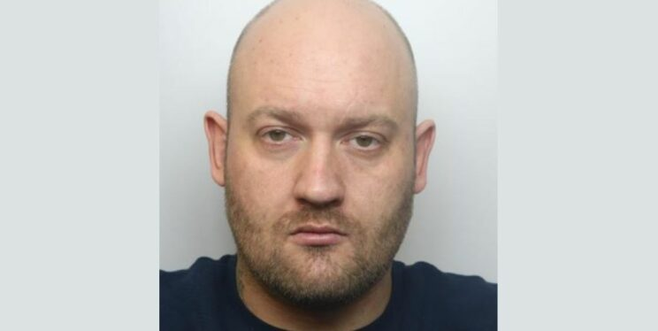

LEGAL NOTICE
This photograph is being released to you for the purposes of:
· Enforcement – providing information to the community to aid the reporting of sentencing;
· Public reassurance – assuring the community that action has been taken;
· Public confidence – assuring the community that future reports will be actioned; and
· Deterrent to the individual in question and others.
Its disclosure relates solely to reporting this particular case/incident. Thereafter, the Constabulary requests that you destroy the image and not use it for any other purpose other than its original intended use.
Any further use of the image thereafter is not authorised by the Constabulary without prior authority of the Chief Constable.
You are reminded of your obligations under the Contempt of Court Act 1981 should this photograph be used again in any unrelated criminal proceedings as well as your obligations pursuant to the General Data Protection Regulation (GDPR).
The use of this image confirms your acceptance of this notice and that you undertake to indemnify the Chief Constable of Avon and Somerset Constabulary in the event of any criminal or civil proceedings arising from unauthorised use by yourselves.
Should you have any queries with this notice or the image, please contact us using the details below.
Corporate Communications Department, Avon and Somerset Constabulary
Force HQ, Valley Road, Portishead, North Somerset BS20 8QJ
mediahq@avonandsomerset.police.uk
01278 646747

