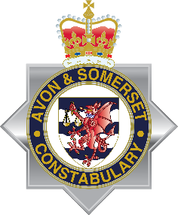

North Somerset Neighbourhood Policing
Inaugural NHW Coordinators’ Masterclass
Saturday 23rd July 2022, 1000hrs

Dear Neighbourhood Watch Coordinator

We would like to invite you to our Inaugural North Somerset Neighbourhood Watch Coordinators Masterclass on Saturday 23rd July 2022 10am-2pm at Conference Room G.08 Castlewood, Clevedon. You will be met on arrival.

Hosted jointly by Weston Town Centre and Nailsea Area Neighbourhood Policing Teams, the event promises to be a superb collection of interactive sessions, networking and guest speakers opened by Ch. Supt Liz Hughes, Avon and Somerset Constabulary Head of Neighbourhood Policing.

We will highlight some superb examples of community activity and provide opportunities to both share great examples of Neighbourhood Watch activity and learn from other Watches and the Police in how we best work together to keep areas safe. Beyond policing, the masterclass will also show fantastic examples of bringing communities closer. You will also see the resources available to NHW to help you make more from your Watch and get the chance to meet and network with your local policing team along with our most senior Neighbourhood Policing officer.

Lunch will be provided along with tea, coffee and biscuits on arrival.

We have already had early enquiries about this event so to book your place please email lee.kerslake@avonandsomerset.police.uk, and we will confirm your secured place by reply. For a limited number with mobility/transport issues we should be able to secure transport to and from the venue.

We, along with Ch. Supt Liz Hughes, Head of Neighbourhood Policing for Avon and Somerset Constabulary look forward to welcoming you. We cannot wait to be part of this celebration and exploration of the potential for our most valued partnership.

Regards

Lee Kerslake
PS2781 Lee Kerslake
Nailsea NPT Sergeant

Gemma Harper
PS2119 Gemma Harper
Weston TCT Sergeant

