E-bike and e-scooter fire safety
You may have seen an increase in the number of lithium-ion battery fires in the media. Lithium-ion batteries are included in a range of products, including e-bikes, e-scooters, mobility scooter and smaller items such as e-cigarettes, electric toothbrushes, mobile phones and laptops.
These images (pictured) are from a recent lithium-ion battery incident where the battery was charged longer than necessary. Firefighters rescued five people from the building due to the escape route being blocked. If you are using rechargeable electronic items make sure you follow our safety advice.
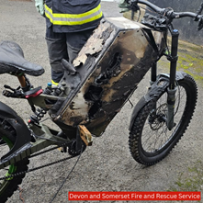
Download

Download
Keep you and your neighbours safe
- Ensure you have working smoke alarms on every level of your home, and in the room where you charge your (lithium-ion battery-powered) electrical items.
- Always use the charger supplied with the device or recommended by the manufacturer, and if you spot any signs of wear and tear or damage, buy an official replacement charger for your product from a reputable seller.
- Keep escape routes clear so you can evacuate quickly and safely.
- Avoid charging the battery overnight.
- Unplug the charger when the battery is fully charged.
- Plug the cable into a main socket rather than an extension lead.
- Have your e-bike or e-scooter serviced if it has been dropped or involved in an accident. This is particularly important if you notice a crack in the battery, where water may have got in.

